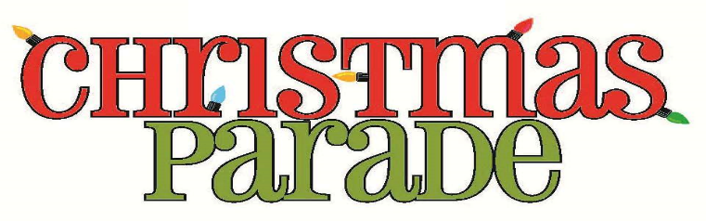
The Town of Kingstree
Presents: “Home for the Holidays”
Sunday, November 21, 2021, at 2:00 P.M.
Tree Lighting event after the parade.

Name of Sponsor: ______________________________________________

(Organization, Church, Business, School, Club, Other)

Type of Unit: __________________________________________________
(Band, Car, Pick-up, Golfcart, Float, Walking, Other)

Name of Entry: _________________________________________________
(Mr., Miss, Queen, Business, Official, Etc.)

Contact Name: _________________________________________________
Contact Phone/Cell#: ____________________________________________
Narrative of Unit: ______________________________________________
Number of Participants: _________________________________________
- Line-up will be at Anderson Brother’s Bank (Martin Luther King Jr. Blvd @ Thurgood Marshall Hwy.) beginning at 1:00 p.m.
- The parade will begin promptly at 2:00 p.m.
- NO ENTRY FEE
- Return completed form NO LATER THAN THURSDAY, NOVEMBER 18, 2021

Float Contacts:
A. D. Kirby Parade Floats Phone: (803) 359-3134 | www.kirbyparadefloats.com (803) 359-3134
Floats by Allen Phone: (843) 889-3166 | www.paradefloatsbyallen.com (704) 283-8308
Southeastern Parade Floats Phone: (803) 917-0644 | www.southeasternfloats.com (803) 655-5534

For more Info Contact:
Town of Kingstree/Christmas Parade Committee
401 N. Longstreet St. Kingstree, SC 29556
Call: 843-355-7484 or 843-355-8156
Facebook: Town of Kingstree

